| Course Name | ITD 2343 – Object Oriented Programming with C# |
| --- | --- |
| Instructor | Mark L. Pranger |
| Student Name | <Ezequiel Barrientos> |
| Due date | <11/4/25> |
| Grade | <grade earned here> |
| Grading Comments | <instructor comments here> |

Test 1: Nine numbers and statistics

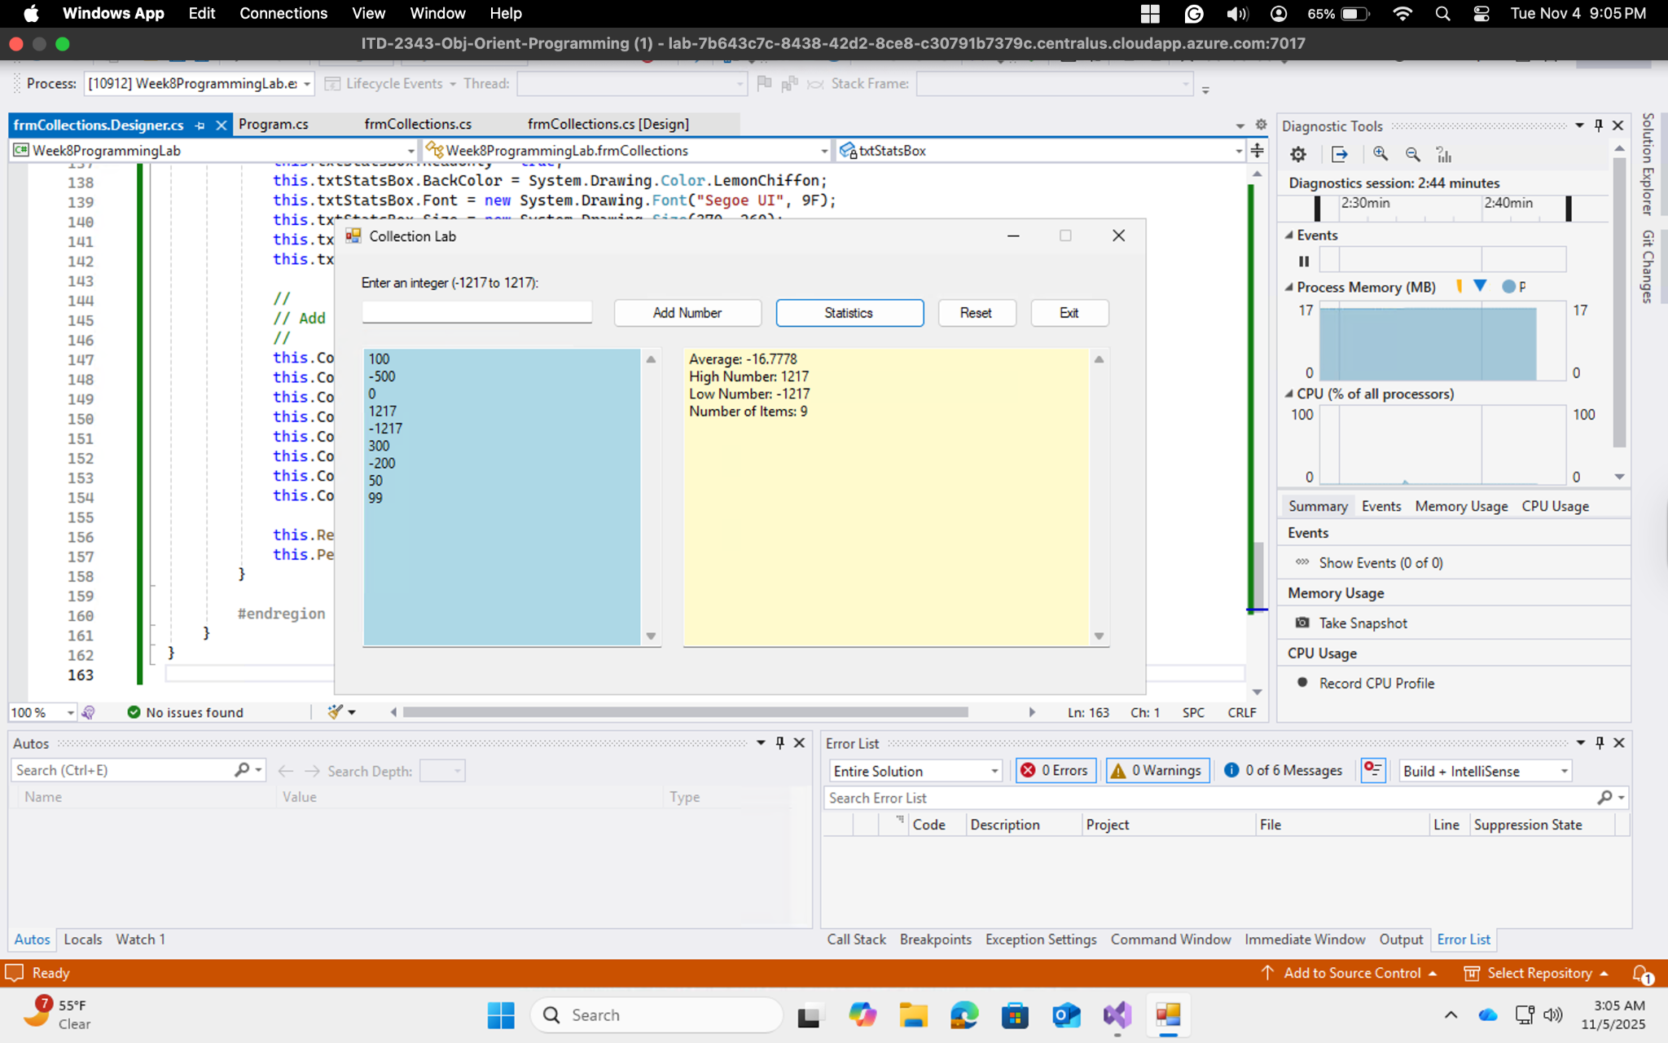

Test 2: Collection Error

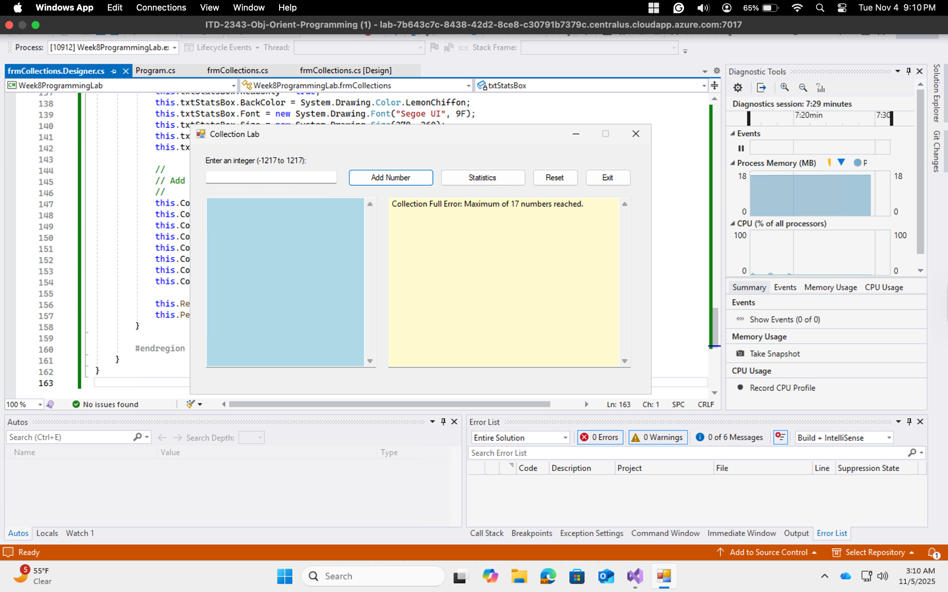

Test 3: Word Input Error

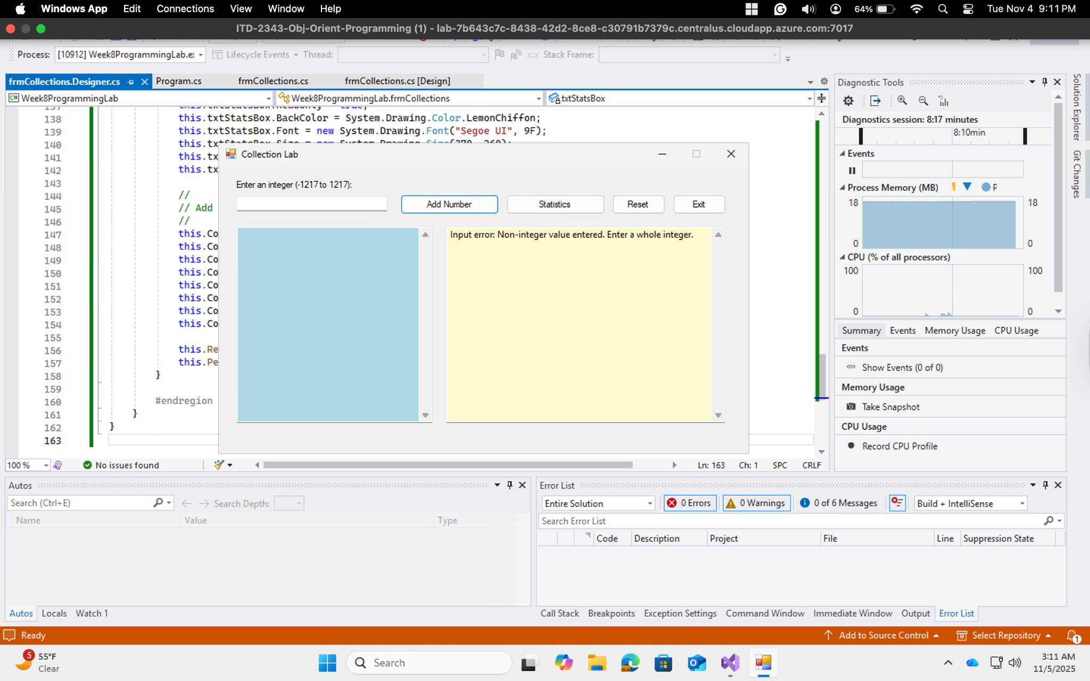

Test 4: Decimal Error

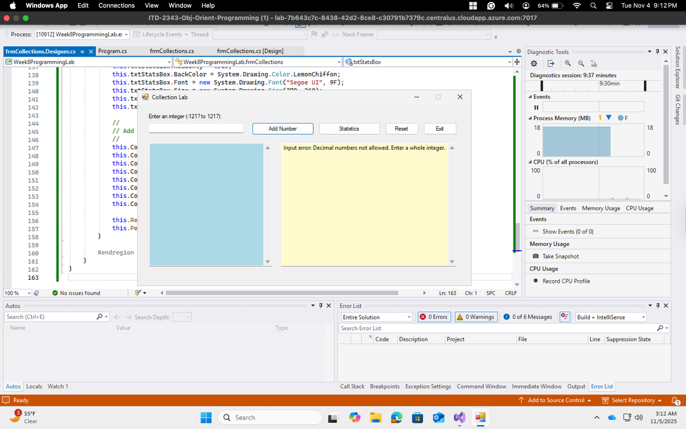

Test 5: Number Too Small Error

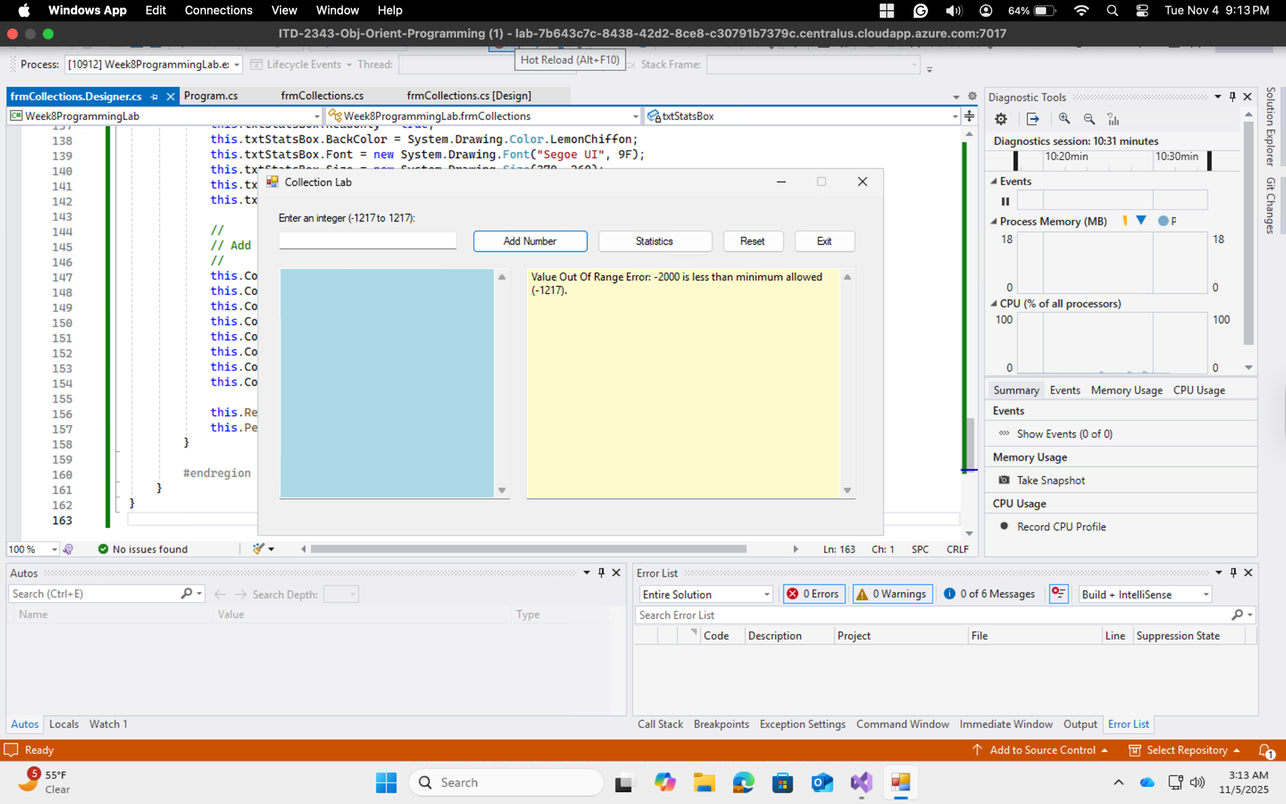

Test 6: Number Too Big

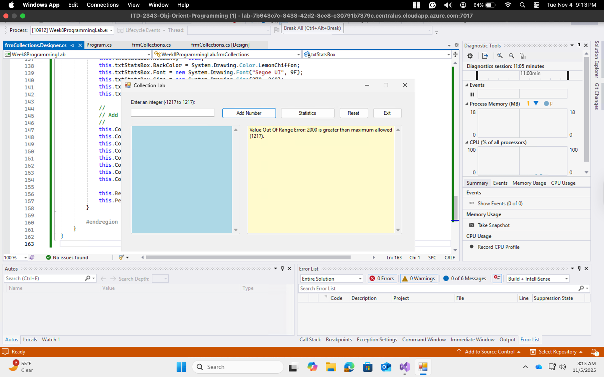

Test 7: Reset Number

